Mine Detonating Sphere-Bot

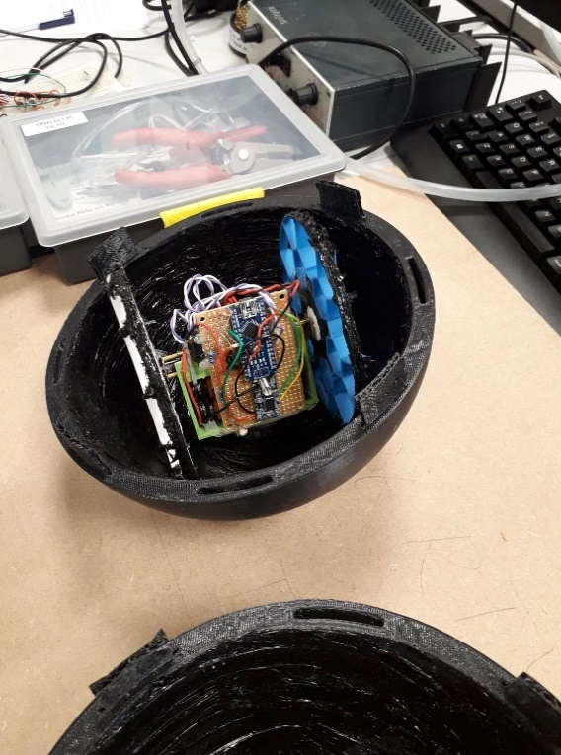Charles Freestone – 10444487  
School of Computing, Electronics and Mathematics  
University of PlymouthPlymouth, United Kingdom  
[charles.freestone@students.plymouth.ac.uk](mailto:charles.freestone@students.plymouth.ac.uk)

Rebecca Harding – 10494676  
School of Computing, Electronics and Mathematics  
University of PlymouthPlymouth, United Kingdom  
[rebecca.harding@students.plymouth.ac.uk](mailto:rebecca.harding@students.plymouth.ac.uk)

*Abstract*— The inspiration for this project came from the armadillo. This creature can curl itself into a ball, protecting its vulnerable parts with plates made of bone acting as armour. While the armadillo moves using its legs, this robot always remains in a spherical shape, and moves using wheels inside the sphere. It is theorised a robot of this design could be used in demining. The sphere rolls over a mine, detonates it, then survives the impact and can move on to detonate further mines. The robot makes use of soft materials rather than hard plates in order to survive impacts.

Keywords — Computer Aided Design; Computer Aided Manufacturing; Finite Element Analysis; tensile/hardness testing; soft mechanisms and materials

# Introduction

# The aim of this project is to design and build a rolling robot that can take high impact from outside forces. This robot can absorb impacts through the materials chosen and spread them over the design increasing the likelihood of survival. It must also be able to roam around inclined environment as this is the area of space it would have to navigate to do its job, including inclines of around 5°.

# The robot consists of a carriage that houses two high torque motors, which rotate a set of wheels that are specially designed to absorb large impacts and maintain traction within the sphere. The sphere adds an extra layer of protection that will take the initial impacts.

# To reduce complexity of the design of the prototype, the robot will be remote controlled, not autonomous. This is so the focus of the project can be on the physical design. The robot will utilize mostly 3D printed parts, so that replacement parts can be reprinted from anywhere where 3D printers are available.

# The robot moving inside of a sphere will allow the centre of gravity of the design to be more easily shifted, this will allow for easier hill climbing in design. It will also allow protective sphere to deform inwards more on an impact as there will be an air gap for it to deform into.

# Design Process and Implementation

## Design Methods

Goals of the project were agreed within the team. A basic Gantt chart was created to manage tasks. Iterative design was used to maximise the potential for testing and optimisation. Rapid prototyping was used in order to reach an optimal design in minimal time.

## Computer Aided Design (CAD)

Throughout the project, Autodesk Fusion 360 was used for all CAD. Designs created needed to fit the dimension constraints of the 3D printers available, and the amount of material required was minimised where possible to reduce printing times. Designs created also account for dimensions of other hardware such as the motors, to allow a good fit.

## 3D Printing

3D printing, a type of Computer Aided Manufacture (CAM), was used to produce all designs. This meant iterations of designs could be produced relatively quickly and iterative improvements could be made. Laser cutting was also available, but this was not utilised because wood would not be a suitable material for any of the parts.

## Materials

A tougher material is desired if the design is to perform better. Izod impact strength tests are a clear way to find better materials. The Izod test will test a material’s ability to absorb energy during its plastic deformation stage. Results are found through adding notches in materials or keeping them un-notched. Our project was created to easily replace broken parts, so only un-notched results will be considered.

After looking at research taken into 3D printed materials it is clear to see that PLA (polylactic acid) is not a favoured material to be impact resistant compared to ABS (acrylonitrile butadiene styrene) plastic. The ABS 3D printed parts reached 304 J/m of absorbed energy, while the PLA part only reached 96.1 J/m in an un-notched Izod test [1, 2].

Creating 3D printed wheels made of ABS plastic would be desired for future iterations of the project. To achieve this a 3D printer would need to be purchased that could sustain such development, such as having a heated bed to ensure correct printing and preventing failure in attaching it to the bed while printing.

The use of flexible NinjaFlex means that impacts can be absorbed. In addition, silicone was used to coat the inside of the sphere and the outside of the wheels. The coefficient of friction of silicone is high, meaning there is less chance of wheel slippage inside the robot. Silicone is also tacky, which means there is additional grip not taken into account by the coefficient of friction. An added advantage of the silicone coating is it gives just a little bit more cushioning to protect the internals of the robot.

## Hardware

The robot moves using two Pimoroni Micro Metal Gearmotors with a 1006:1 gear ratio. This provides a high torque allowing ease of movement and the ability to move up a slight incline. The robot is remote controlled using an HC-12 radio module inside the sphere and a radio module on a controller. The controller features four push buttons to allow the user to control the movement of the robot. Both the robot and the controller use an Arduino Nano.

The wheels need to be able to absorb impacts, in order to protect the motors from damage. Three wheel designs were initially considered. One inspired by the complex wheel structure of the SandFlea robot [3], one inspired by a Mars Rover using spiral shapes as shock absorbers [4] and one that simply used a rigid inner part and a soft tyre on the outside made from NinjaFlex, like a car tyre. Each of these three designs were tested, as shown later in this paper, and the final wheel design was altered afterwards.

## Control

Code was produced using the Arduino IDE. Each of the push buttons on the controller represent a different direction: forwards, backwards, left and right. Each of the buttons are connected to a different Arduino digital input pin. When an input is high, the Arduino sends out an ASCII character using the radio module. The characters can be “w”, “a”, “s” and “d”. On the robot side, the other radio module receives the character and it is interpreted by the code. An H-bridge is used to control the motors. There are four inputs to the H-bridge: motor 1 forwards, motor 1 backwards, motor 2 forwards and motor 2 backwards. When no button is being pressed on the controller side, a space character is sent which signals the motors to cease movement.

The robot does not travel while it is turning, it merely turns on the spot, by having each motor move in opposite directions. The speed of the moving motors is constant, as PWM is not used. This could be considered in the future to allow the robot to veer left or right, or to move slowly in certain situations.

Fault detection was added as a supplementary feature. Light dependant resistors (LDRs) are used inside of the sphere. If the sphere is broken open by an impact, the LDR values will change and thresholds set in the Arduino determine that there has been an error. An “e” character is sent from the robot radio module to the controller module. The controller Arduino then sets an output pin high in order to turn on an LED. The LED indicates to the user that the robot has been damaged.

# Analysis

Analysis was conducted on the Sphere-Bot to calculate the amount of force required from the motors in order to move the sphere up an inclined plane. All weight of the Sphere-Bot has been accounted for including the carriage and other internals.

## Assumptions

The weight of the internal body includes all electronics and materials for the carriage and wheels.

The weight of the internals is considered to be centralised around the motor shaft with equal distribution.

The ball will not roll back down the hill, it will only slip back down the hill. Thus, analysis will be taken on assuming a rectangular shape instead of spherical.

The hill will be modelled at a uniform gradient with no loose material. Loss due to this loose material is ignored.

Movement forwards only considers if the centre of gravity is past the midpoint of the main body. This is to simplify calculations to be taken. Through trial and error, if the carriage has enough friction and force to raise itself past the centre of gravity then the ball will rotate forwards.

## Free Body Diagram

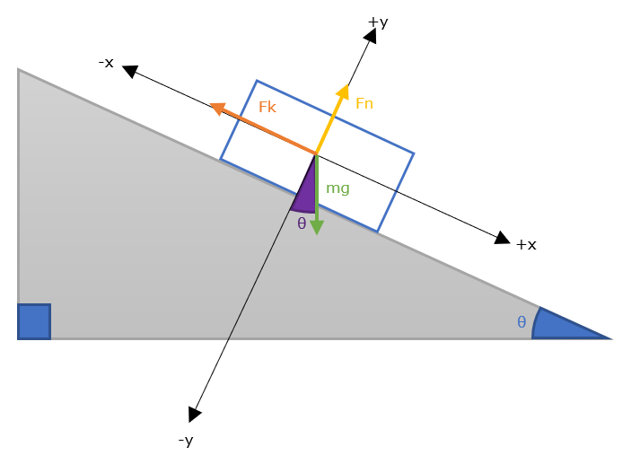

Figure 1: Free body diagram with given assumptions

## Equations

The following equations are based on the free body diagram in Figure 1. The forward force represented by Fk is the force required for the robot to travel up the inline.

The forwards force produced by the robot must exceed the component of its weight acting along the slope and the force due to friction. This is expressed in Equation 1 [5].

Equation : Minimum force required from the robot

The component of weight acting along the slope is derived from the weight of the robot. This is the parallel force, shown in Equation 2.

Equation : Parallel component of weight

Equation 3 shows the other component of weight. This acts perpendicular to the slope.

Equation : Perpendicular component of weight

The normal force, which pushes up against the robot, has the same magnitude as the perpendicular component of weight, but in the opposite direction. Therefore Equation 4 is the negative of the perpendicular force.

Equation : Perpendicular component of weight

The force due to friction is based on the normal force, modified by the coefficient of friction. The greater the coefficient of friction, the greater the force due to friction will be. This force of friction is shown in Equation 5.

Equation : Resistive force due to friction

Equation 6 shows the final minimum force required for the robot.

Equation : Full equation for required force

The mass of the robot is 0.75kg. The coefficient of friction of NinjaFlex is 0.69[6].

As an example, the minimum force required for the robot to move uphill on a 5° incline in shown in Equation 7.

Equation : Force required to move uphill on a 5° incline

## Discussion

The amount of force required for the robot to climb an incline of 5° therefore is 5.70N. Experimentation will need to be carried out to see what parameters are necessary to allow the robot to reach this incline. This will include increasing the mass of the robot and the coefficient of friction μs for the internals of the robot.

# Simulations

## Finite Element Analysis: Sphere

### Method

All Finite Element Analysis was completed using Autodesk Fusion 360. The 3D design was used. The sphere is made up of two interlocking hemispheres. For this test, only one hemisphere was used. The same force is applied to the sphere for both measurements, but the material of the sphere is changed to be either PLA or NinjaFlex.

### Results

Figure 2.A shows the result for PLA, Figure 2.B shows the result for NinjaFlex. Figure 2.C and Figure 2.D show a different view for PLA and NinjaFlex respectively and include surface probes to show the displacement of the sphere at the location of the applied force.

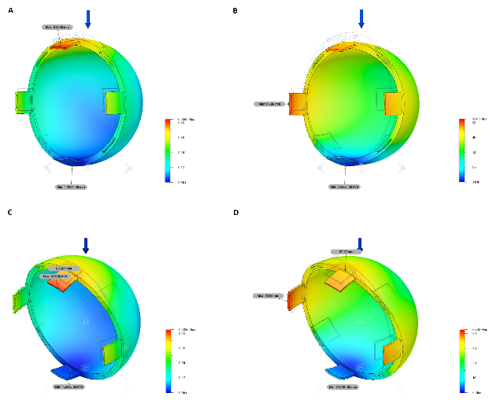

Figure 2: Sphere simulation results

Table 1 shows the displacement of the sphere for PLA and NinjaFlex.

|  |  |  |
| --- | --- | --- |
| **Displacement (mm)/Material** | **PLA** | **NinjaFlex** |
| **At location of applied force** | 0.4357 | 52.27 |
| **Maximum displacement** | 0.5086 | 63.88 |

Table : Table to show measured displacement

### Discussion

It can be clearly seen that the sphere deforms a lot more when made from NinjaFlex. This is a desired effect as it will protect the internals from impacts, therefore NinjaFlex was used when printing the sphere.

## Finite Element Analysis: Wheels

### Method

The wheel designs tested were the designs that were also 3D printed. Five wheel designs were tested.

For each wheel, a range of forces were applied, and the maximum displacement was observed. The forces were 50N, 100N, 150N, 200N and 250N.

### Results

Figure 3 shows the results. “SF” represents the SandFlea inspired wheels and three thicknesses of struts were tested: 1mm, 1.2mm and 2mm. “Tyre” is the wheel and tyre design. “Rover/10” represents the Mars Rover inspired wheel, but the values have been scaled down by a factor of 10 as the displacement values were very large.

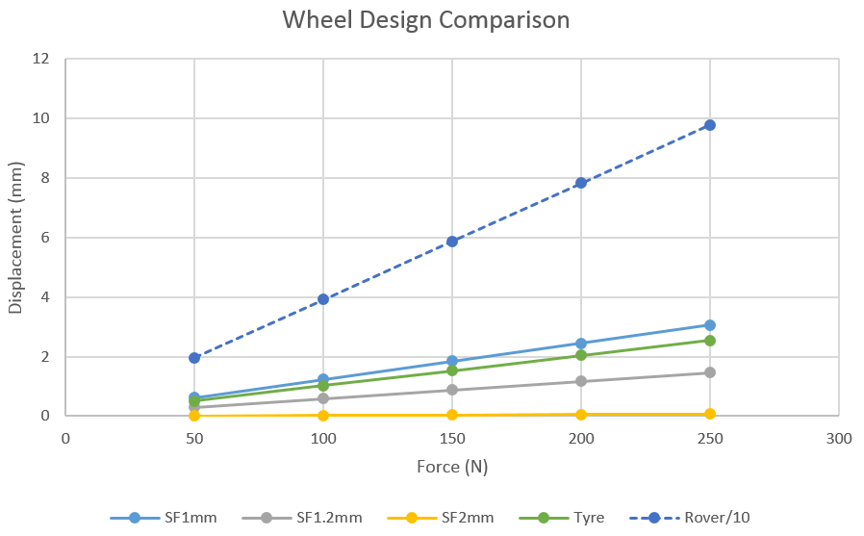

Figure 3: Graph to show the comparison of different wheel designs

Figure 5: Graph to show the test on compression test on different wheel designs

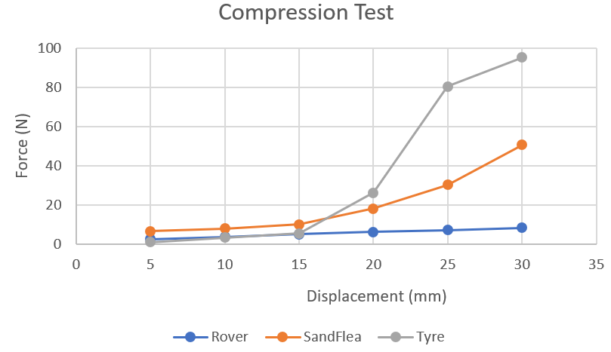

### Discussion

The displacement values were smallest for the SandFlea inspired wheels with 2mm thickness. This design is undesirable as the wheels would not provide much dampening. The displacement values for the Mars Rover inspired wheels were largest. However, part of the reason for the large values is that the values recorded were the maximum displacement. As seen in Figure 4, the inner, spiral parts deform more than the outside of the wheel.

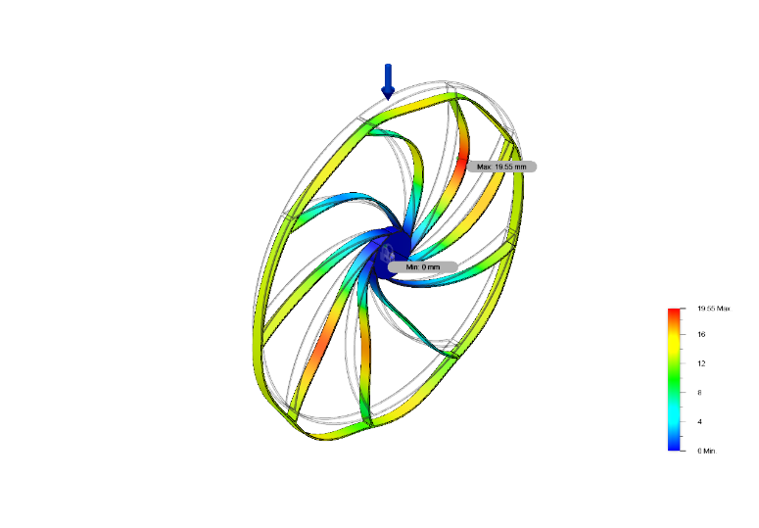

Figure 4: Example of Rover inspired wheel results

Overall, the SandFlea inspired wheel with 1mm thickness was deemed to be the most effective design due to the balance of dampening abilities due to deformation and the ability to hold its structure sufficiently. This decision was based on results from other tests as well as this one.

# Experiments

## Preliminary Compression Testing

### Method

To better understand how fractures manifest in 3D printed objects and how designs used in industry distribute force across themselves outside of simulations. The three wheel designs previously mentioned were used; Rover inspired, SandFlea inspired and Tyre. The study was carried out at the University of Plymouth’s Testing Laboratory. A compression test machine was used to initially test the wheel designs until the point of breakage.

Force was applied until a deformation of 30mm was created. The wheels were all kept the same depth (5mm) and compressible material (struts) was also kept to a similar thickness, 0.8mm. The depth was chosen to reduce slip in the experiment. The thickness of the material was chosen to allow adequate compressions. This meant adjusting the infill of the NinjaFlex tyre so that the outside supports became the same thickness.

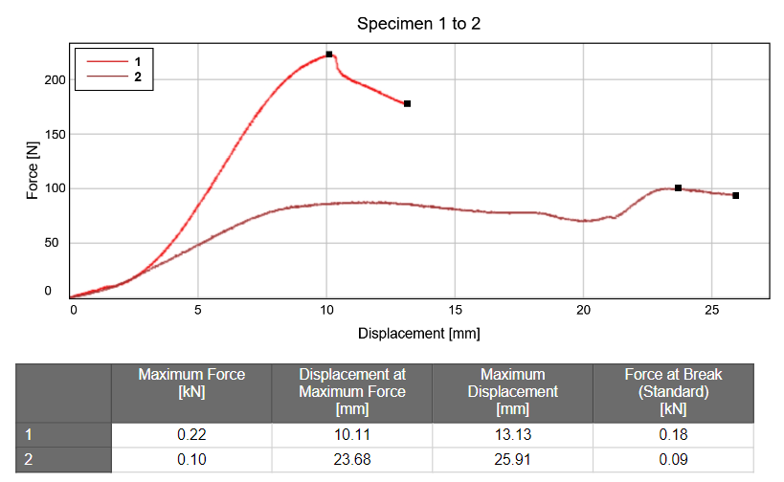

Figure 6: Graph to show compression test of different wheel thicknesses

### Results

Figure 5 shows the results from the initial compression test. From these results its clear to see that the SandFlea inspired design is the best for maintaining a uniform distribution across the test. The tyre design is best for being compliant at lower compressions (when the NinjaFlex material can be functional) but stays rigid at higher compressions. The Rover inspired design did not perform well.

### Discussion

From the results in the test the SandFlea inspired design will be chosen. This is due to its compliancy throughout the test staying uniform. The tyre design may be included in future designs if more compliancy is desired at lower levels of force.

## Further Compression Testing

### Method

### After the initial compression test had been undertaken, an improved investigation was taken into the compression of the wheels at different thicknesses.

### After preliminary tests were taken it was noted that the SandFlea inspired wheels suited the task the best. A compression test machine was used to compare two different variations of the design: struts with a thickness of 1mm or of 1.2mm.

### Results

In Figure 6, Line 1 represents the SandFlea inspired wheel with thickness of 1.2mm and Line 2 represents the SandFlea inspired wheel with a thickness of 1.0mm. This test clearly showed that the thicker wheels held up to greater forces than the thinner ones. That wasn’t surprising, but the thinner wheels didn’t fracture as severely as the thicker design. From the observed video of the testing process, found in the project GitHub repository, this was due to the wheel not fracturing down the layers like the thicker counterpart, but instead fracturing across. This meant that the wheel then started to support itself on the other struts in the wheel.

### Discussion

Even though the 1.2mm wheels took a higher amount of force to break, they broke after the PLA material had already fractured between the layers. This is not feasible for the design and so the 1.0mm wheels will be chosen. The fracturing can also be addressed by adding silicone over the outside of the wheels, to prevent them from peeling apart under high forces.

## Hill Climb Test

### Method

Considerations to combine into the design are as follows: the carriage needs to be able to roll past the centre of gravity of the sphere, so past the middle point of the sphere, to allow the sphere to rotate smoothly. The friction needs to be high enough to prevent slippage of the wheels to the inside of the sphere. The weight of the carriage needs to be high enough to counteract the rotation force the sphere will have to roll back down the hill.

From looking at the calculations and basic principles a simple test can be carried out, changing variables such as the height of the incline, weight carried by the carriage and materials used to increase friction. All to confirm results from the above section. A plank of wood will be used as an adjustable ramp for the robot to climb.

### Results

Table 2 shows the results from the Hill Climb Test. From these results it’s clear to see that adding silicon increased the friction enough for the sphere to increase the amount it could climb. It prevented slip from the wheels to the inside of the sphere. However, at higher weights the motors would fail to rotate. This was probably due to the amount of force that the motors had to apply being too great.

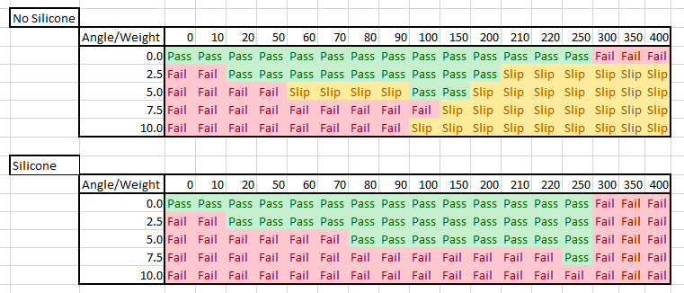

Table : Table to show the difference when adding silicone to inner surface of the robot for varying weights

### Discussion

The difference between results in the two tables shows that adding silicone to the internals of the robot (inside of the sphere and outside of the wheels) increases the amount of friction obtained by the design and thus increases the amount of energy transferred from the motors to the robot’s movement. The tacky property of the silicone paired with the higher value for coefficient of friction allowed this change.

# Conclusion

## Wheels

After concluding all tests, it was decided that the SandFlea inspired wheel was the most effective. The design was improved further. It was modified to include a NinjaFlex section. The final wheel design is shown in Figure. The NinjaFlex piece acts like suspension for the wheels, further dampening impacts and compressions that the robot incurs. PLA is still used for the drive shaft (for allowing a rigid material for the motor axel to hold onto) and the struts of the wheel. The outer circle of the wheel was made thinner to allow further flexibility in absorbing impacts.

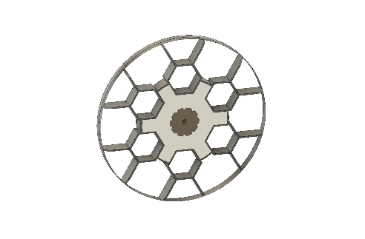

Figure 7: CAD final wheel design

Figure 8 shows the way in which the wheels deform. The forces were, as before, 50N, 100N, 150N, 200N and 250N.

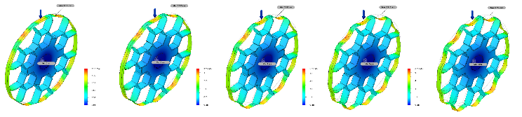

Figure 8: FEA results for final wheel design

Figure 9 shows the comparison of the final design with the original design simulations. Due to the addition of a NinjaFlex piece, this design has a greater displacement than the other SandFlea inspired wheels. This means there is a greater dampening effect in the case of impacts, so the internals will be better protected.

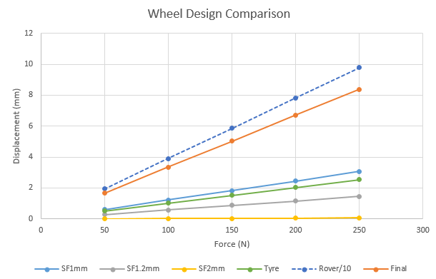

Figure 9: Comparison including the final wheel design

## Final Thoughts

The robot created in this project was able to climb an incline of 7.5° while being contained in a protective sphere, surpassing previous milestone of reaching 5° of incline. The protective layer in tandem with the wheels allowed the robot to absorb more impacts that just having the internal carriage and was able to make full use of the flexible NinjaFlex material. The use of rapid prototyping throughout this project allowed the project to go through quick development, allowing the design to quickly overcome design issues.

## Future Improvements

The improvements to the robot would be to first print the design using ABS plastic (to increase toughness) and time allowed for printing NinjaFlex (preventing errors in the printing process) to see if the design would increase in performance with those changes.

By scaling the robot design and incorporating a location method, the robot could be used as part of a swarm, which would increase the efficiency in the clearing an area of mines.

Some form of sensing could be added so that the robot can detect a mine and travel towards it, rather than having to cover the entire area.

##### References

1. "Comparison of typical 3D printing materials", 2015.igem.org, 2019. [Online]. Available: http://2015.igem.org/wiki/images/2/24/CamJIC-Specs-Strength.pdf. [Accessed: 29- Nov- 2018].
2. "Izod Impact Strength Testing of Plastics", Matweb.com, 2019. [Online]. Available: http://www.matweb.com/reference/izod-impact.aspx. [Accessed: 29- Nov- 2018].
3. "SandFlea | Boston Dynamics", Bostondynamics.com, 2018. [Online]. Available: https://www.bostondynamics.com/sandflea. [Accessed: 10- Nov- 2018].
4. "Mars Exploration Rover Mission: Spotlight", Mars.nasa.gov, 2018. [Online]. Available: https://mars.nasa.gov/mer/spotlight/wheels01.html. [Accessed: 10- Nov- 2018].

[5] S. Holzner, "Calculating the Force Needed to Move an Object Up a Slope - dummies", dummies, 2018. [Online]. Available: https://www.dummies.com/education/science/physics/calculating-the-force-needed-to-move-an-object-up-a-slope/. [Accessed: 23- Nov- 2018].

[6] J. Farstad, "Surface Friction of Rapidly Prototyped Wheels from 3D-Printed Thermoplastic Elastomers: An Experimental Study", *ScienceDirect*, 2019. [Online]. Available: https://www.sciencedirect.com/science/article/pii/S2212827117300793. [Accessed: 05- Nov- 2018].